    - Search activity – Finding the Signature Financial patent
Do a search for the Signature Financial patent and find the patent number.
A PCT application was also filed for this invention. Find this and provide the publication number and a quick review of the search report.
Model Answer:
Search for ‘Signature Financial’ on the Advanced Search page of Espacenet.
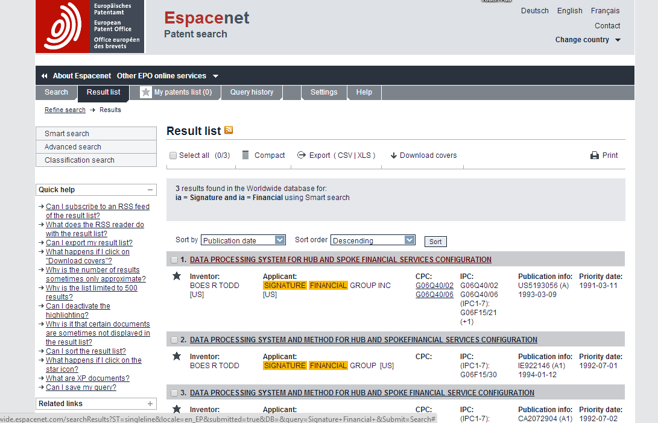
There is one US patent in the results list: US5193056. Click on the title:
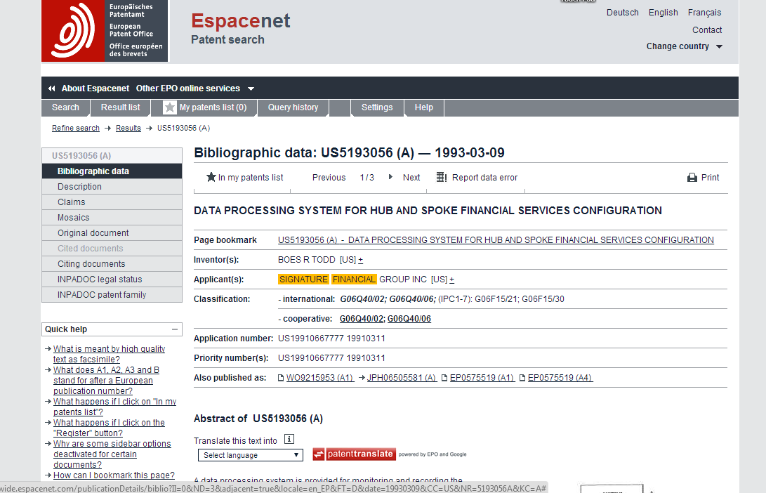
This gives the PCT publication number: WO9215953.

Click on this to obtain the PCT publication
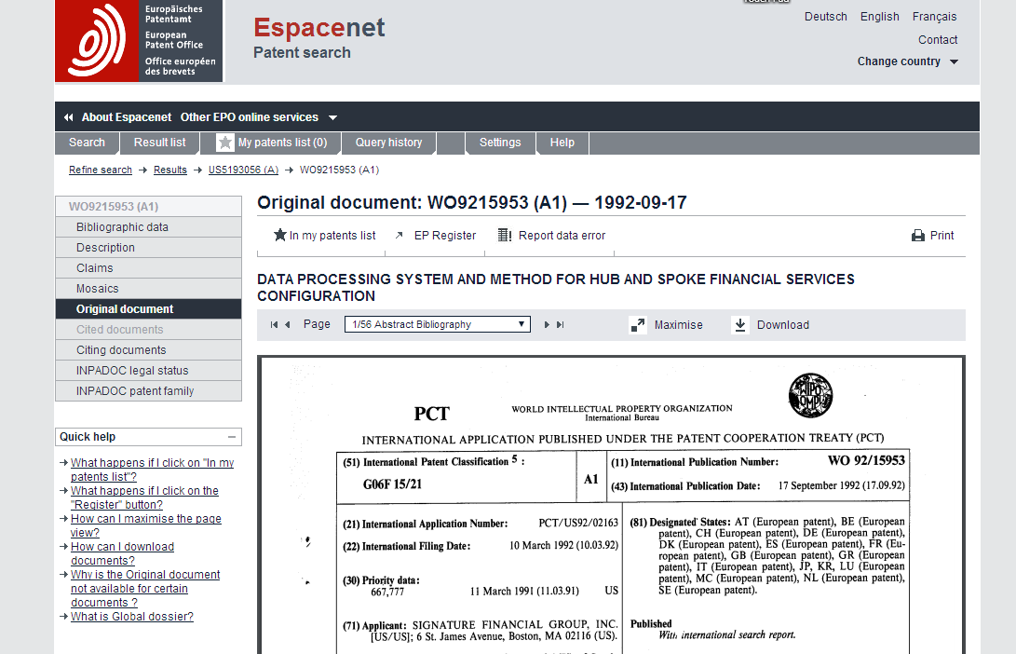

.. and go to pages 55 and 56 to find the search report:

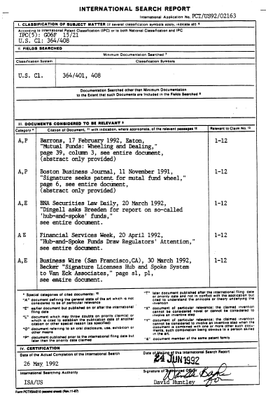 | 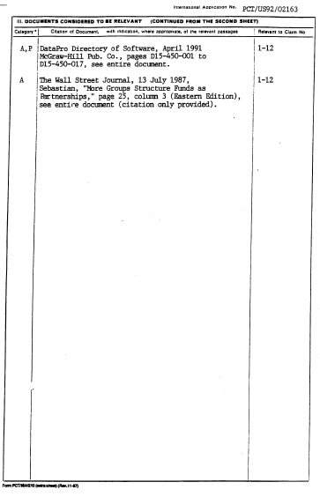
The search report has “A”, “E” and “P” citations. , “A” citations disclose the general state of the art; “E” citations refer to documents published after the international filing date; and “P” citations refer to documents published earlier than the filing date but later than the priority date. Accordingly both “E” and “P” citations as well as “A” citations do not threaten the novelty or inventiveness of the invention set out in the claims of the PCT publication.
However that is not the end of the story. Check the subsequent history of this patent, for instance on Wikipedia at: https://en.wikipedia.org/wiki/1-Click

